|  |  |
| --- | --- |
| **Name :-** | Aryan Dilipbhai Langhanoja |
| **Enroll No: -** | 92200133030 |

## Basics of NOT gate and its application in an 8-bit one's complement circuit

* **Aim** :-

The aim of this experiment is to apply a basic NOT gate logic in a 8 -bit one’s complement circuit. The user will be able to build, simulate and verify the 8-bit one’s complementing circuit using the generalized simulator (a blank canvas with click & place facility for selected gates).

* **Pre-test :-**

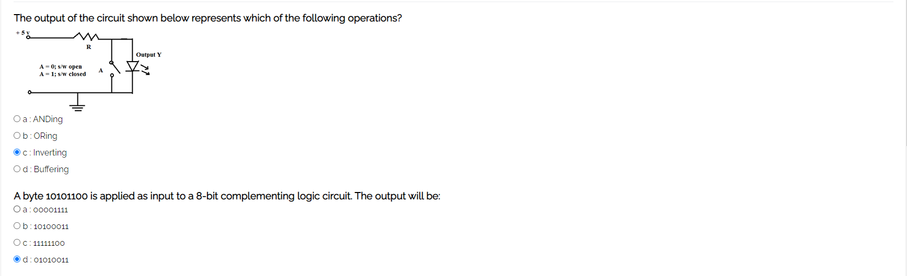

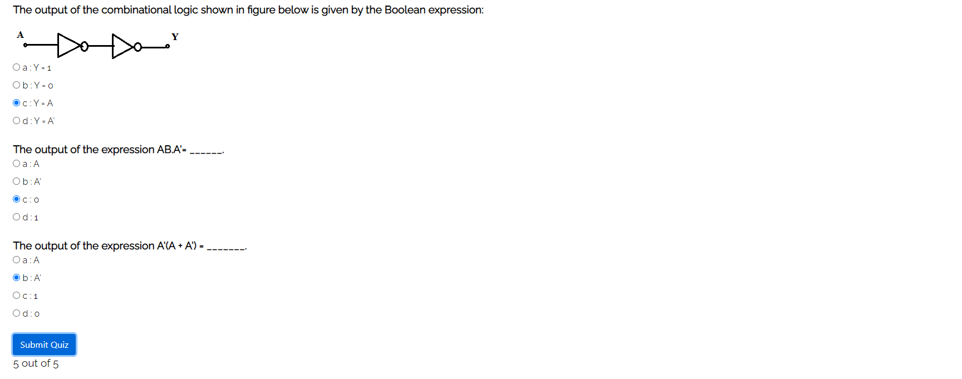

* **Simulation :-**

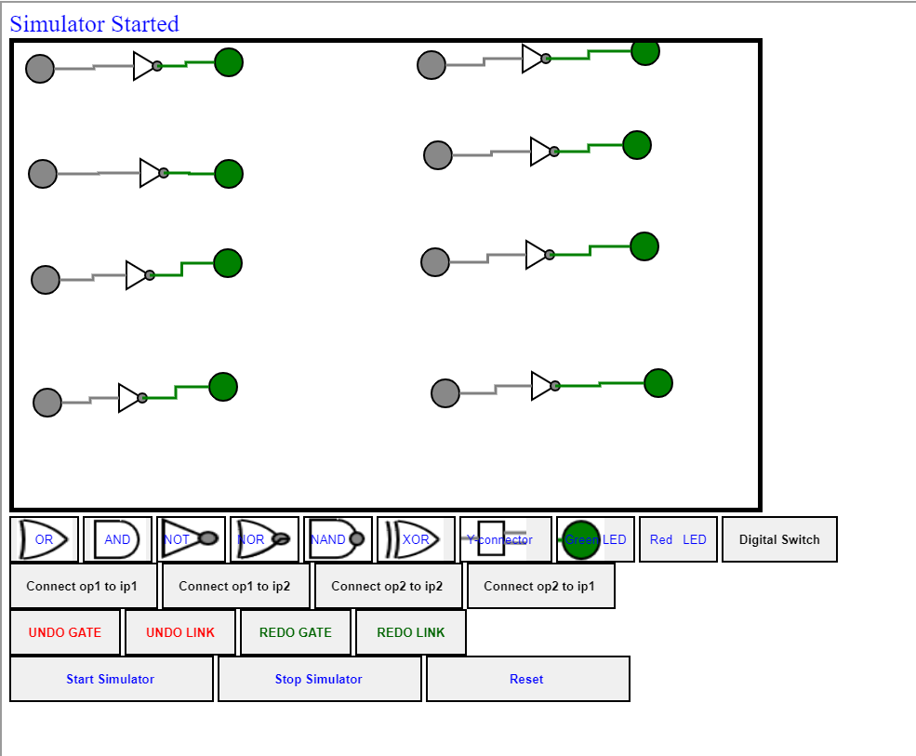

* 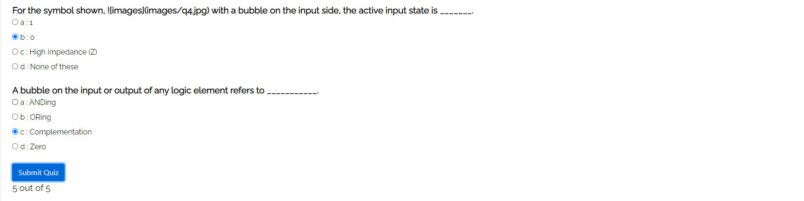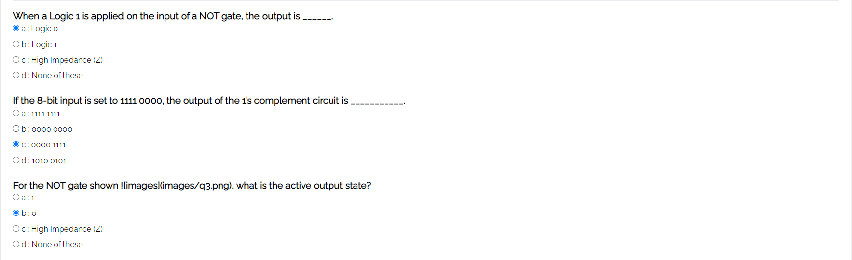**Post-test :-**